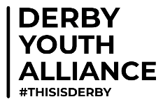 Expression of Interest
If you wish to express your interest in collaborating with like-minded delivery partners as part of the Derby Youth Alliance please complete your details in the form below:
Organisation Name _________________________________________________
Address ___________________________________________________________
__________________________________________________________________
Lead Contact _______________________________________________________
Email _____________________________________________________________
Phone ____________________________________________________________
Please provide below a brief summary of the types of support and/or activities you currently provide. Include, if relevant, times, frequency, age and/or target groups and other related information. This can be broken down to physical, creative, educational and any other opportunities you feel would enhance the Derby Youth Alliance, if applicable please also include approximate rates/costings:

I ( insert name )
on behalf of ( insert organisation )
confirm our interest in becoming a delivery partner of the Derby Youth Alliance:

Signature ________________________________ Date ______________

Email form to: helen.britten@communityactionderby.org.uk or michelle.butler@communityactionderby.org.uk

